Implementing the Multi-Level Feedback Queue (MLFQ) Scheduler Using Semaphores
A Technical Article on Operating-System Scheduling and Synchronization

Document Information
Field | Details
Title | Implementing the MLFQ Scheduling Algorithm Using Semaphores
Authors | Najla Davarpanah
Course | Embedding Systems
Instructor | Majid Shamshirgaran
University / Institution | Eshragh University
Date | October 2026
Version | 1.0
Keywords | MLFQ, Scheduling, Semaphore, Synchronization, Concurrency, Operating Systems

Abstract
The Multi-Level Feedback Queue (MLFQ) is one of the most widely used CPU-scheduling algorithms because it approximates Shortest-Job-First behavior without knowing job lengths in advance, while keeping interactive tasks responsive. In a real kernel, however, the scheduler's queues are shared by many threads: the dispatcher, the timer interrupt handler, threads that become ready, and threads that block on I/O. Without proper synchronization these shared structures suffer from race conditions that corrupt queues and lose processes. This article presents a complete design for implementing MLFQ using counting and binary semaphores. We describe the data structures, the semaphore roles, the dispatcher and enqueue algorithms in pseudocode, a flowchart of the scheduling cycle, a worked example, and an analysis of correctness and performance. The design is simple, portable, and free of deadlock and starvation when the priority-boost rule is applied.

1. Introduction
CPU scheduling decides which ready process runs next. Classic algorithms such as FCFS, Round Robin, and SJF each optimize a single goal. FCFS is simple but suffers from the convoy effect; Round Robin gives fair turnaround for short jobs but poor average turnaround; SJF minimizes average waiting time but requires knowledge of the future. MLFQ resolves this tension by learning from each process's behavior: it observes how long a process uses the CPU and adjusts its priority accordingly.
Two problems must be solved to build a working MLFQ:
- The scheduling policy: how many queues exist, how priorities change, and how long each quantum lasts.
- The synchronization problem: the queues are shared mutable data. Several execution contexts insert and remove processes concurrently, so every access must be protected.
This article focuses on the second problem and uses semaphores, the primitive introduced by Dijkstra, as the only synchronization tool.

2. Background

2.1 MLFQ Rules
A classical MLFQ obeys the following five rules:
Rule | Description
R1 | If Priority(A) > Priority(B), A runs and B does not.
R2 | If Priority(A) = Priority(B), they run in Round Robin using the quantum of that queue.
R3 | A new process enters the highest-priority queue.
R4 | If a process uses its whole quantum, its priority is reduced (it moves down one queue).
R5 | After a period S, all processes are moved to the top queue (priority boost) to prevent starvation.

2.2 Semaphores
A semaphore is an integer variable accessed only through two atomic operations:
- wait(S) (also P): decrements S; if the result is negative, the caller blocks.
- signal(S) (also V): increments S; if there are blocked callers, one is awakened.
A binary semaphore takes the values 0 or 1 and acts as a mutual-exclusion lock. A counting semaphore represents the number of available resources, which in our case is the number of ready processes.

3. System Model and Data Structures
We assume a system with N = 3 queues, although the design generalizes to any N.
Queue | Priority | Time quantum | Policy
Q0 | Highest | 4 ms | Round Robin
Q1 | Medium | 8 ms | Round Robin
Q2 | Lowest | 16 ms | FCFS
Each process is described by a Process Control Block (PCB):
Field | Type | Meaning
pid | int | Unique process identifier
level | int | Current queue index
remaining | int | Remaining CPU burst time
used | int | CPU time used in the current quantum
state | enum | NEW, READY, RUNNING, WAITING, TERMINATED
Every queue Qi is a linked list with enqueue and dequeue operations. These operations are not thread-safe by themselves; the semaphores provide the safety.

4. Semaphore-Based Design

4.1 Semaphore Roles
The design uses three kinds of semaphores:
Semaphore | Type | Initial value | Purpose
mutex[i] | Binary | 1 | Protects queue Qi against concurrent insertion and removal
ready | Counting | 0 | Counts the total number of ready processes in all queues; the dispatcher sleeps when it is 0
cpu | Binary | 1 | Guarantees that only one process holds the CPU at a time
boost_mutex | Binary | 1 | Prevents the priority boost from running at the same time as enqueue or dequeue operations

4.2 Design Principles
- Producer–consumer structure. Threads that make a process ready are producers; the dispatcher is the consumer. The counting semaphore ready links them: producers signal it, the dispatcher waits on it. This avoids busy waiting.
- Fine-grained locking. Each queue has its own mutex, so a producer that inserts into Q0 does not block a thread working on Q2.
- Lock ordering. When a thread needs more than one lock (for example, during a boost), it always acquires boost_mutex first, then mutex[0], mutex[1], mutex[2] in increasing order. A fixed order prevents circular waiting and therefore deadlock.

5. Algorithms

5.1 Making a Process Ready
procedure make_ready(P):
wait(boost_mutex)
i = P.level
wait(mutex[i])
enqueue(Q[i], P)
P.state = READY
signal(mutex[i])
signal(boost_mutex)
signal(ready) // wake the dispatcher

5.2 The Dispatcher
procedure dispatcher():
loop forever:
wait(ready) // sleep if no process is ready
wait(boost_mutex)
for i = 0 to N-1:
wait(mutex[i])
if Q[i] is not empty:
P = dequeue(Q[i])
signal(mutex[i])
break
signal(mutex[i])
signal(boost_mutex)
wait(cpu)
run P for min(quantum[P.level], P.remaining)
signal(cpu)
update_after_run(P)

5.3 Updating Priority After Running
procedure update_after_run(P):
if P.remaining == 0:
P.state = TERMINATED
else if P blocked for I/O:
P.state = WAITING // keeps its level (rule R4 not applied)
else: // used the full quantum
P.level = min(P.level + 1, N-1)
make_ready(P)

5.4 Priority Boost
procedure boost(): // called every S milliseconds by a timer
wait(boost_mutex)
for i = 1 to N-1:
wait(mutex[i])
while Q[i] is not empty:
P = dequeue(Q[i])
P.level = 0
wait(mutex[0])
enqueue(Q[0], P)
signal(mutex[0])
signal(mutex[i])
signal(boost_mutex)

6. Scheduling Flowchart
The flowchart below summarizes one iteration of the semaphore-based dispatcher. (The diagram is placed directly under this heading.)
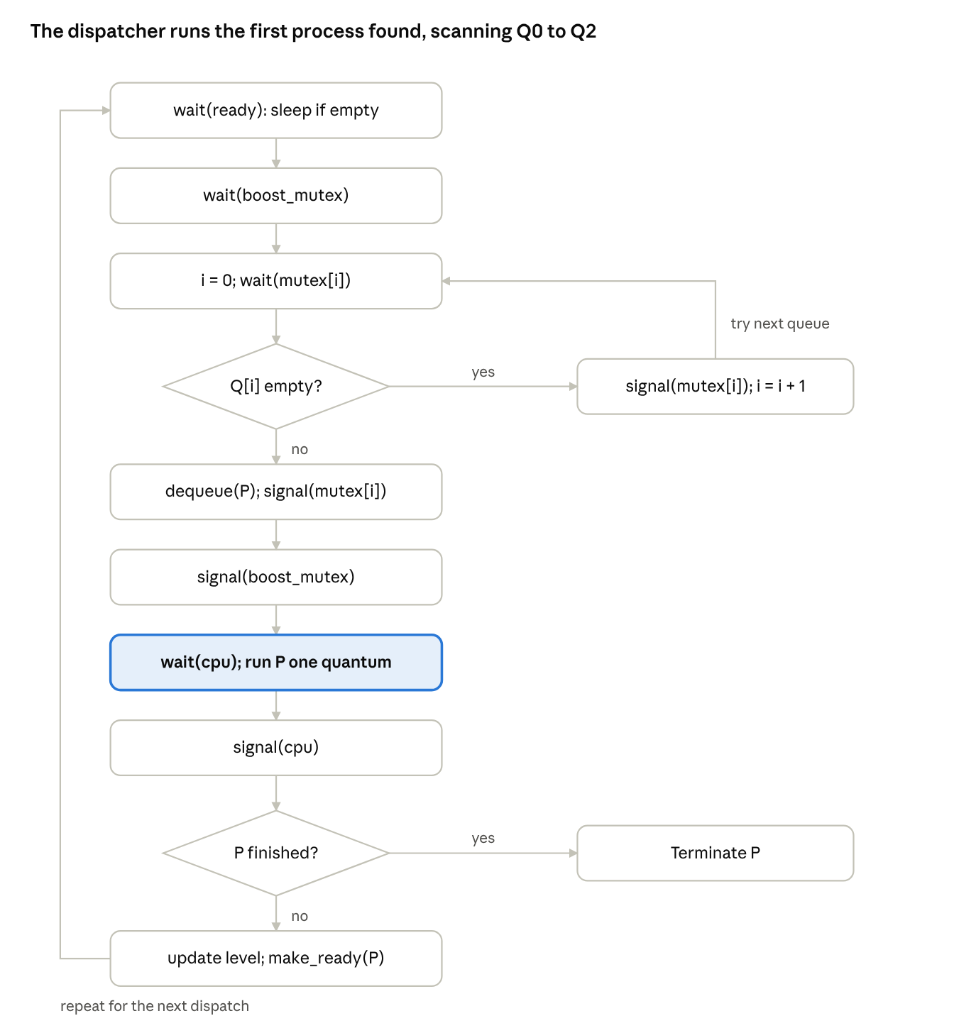
semaphore-based dispatcher · 2 decisions, 2 loops
The dispatcher sleeps on ready, scans Q0 to Q2 under each queue's mutex, runs the first process it finds, and returns it to a queue unless it has finished.

7. Worked Example
Consider three processes arriving at time 0 with the burst times shown below. Quanta are 4, 8 and 16 ms.
Process | Burst (ms) | Behavior
A | 20 | CPU-bound
B | 6 | Short, interactive
C | 12 | Medium
Execution trace:
Time interval | Running | Queue | Action
0–4 | A | Q0 | Quantum expires; A moves to Q1 (remaining 16)
4–8 | B | Q0 | Quantum expires; B moves to Q1 (remaining 2)
8–12 | C | Q0 | Quantum expires; C moves to Q1 (remaining 8)
12–20 | A | Q1 | Quantum expires; A moves to Q2 (remaining 8)
20–22 | B | Q1 | B finishes at 22
22–30 | C | Q1 | C finishes at 30
30–38 | A | Q2 | A finishes at 38
Resulting metrics:
Process | Completion | Turnaround | Waiting
A | 38 | 38 | 18
B | 22 | 22 | 16
C | 30 | 30 | 18
Average |  | 30.0 | 17.3
The short job B finishes much earlier than the CPU-bound job A, which is exactly the behavior MLFQ is designed to produce.

8. Correctness Analysis
Mutual exclusion. Every access to queue Qi happens between wait(mutex[i]) and signal(mutex[i]). Because mutex[i] is binary and initialized to 1, at most one thread can be inside the critical section of a given queue.
No lost wake-up. Each successful enqueue is followed by exactly one signal(ready), and each dispatcher iteration performs exactly one wait(ready). The value of ready therefore always equals the number of processes waiting in the queues, and the dispatcher never sleeps while work exists.
Deadlock freedom. The four Coffman conditions cannot all hold. Circular wait is impossible because all threads acquire locks in the same global order: boost_mutex, then mutex[0], mutex[1], mutex[2]. The dispatcher never holds a queue mutex while waiting on ready or cpu.
Starvation freedom. Under pure rule R1, low-priority processes may wait forever. The periodic boost (rule R5) guarantees that every process reaches Q0 at least once per period S, so each process receives CPU time within a bounded interval.

9. Performance Considerations
Aspect | Observation
Lock contention | Per-queue mutexes reduce contention compared with one global lock.
Dispatch cost | O(N) to find the first non-empty queue; O(1) enqueue and dequeue.
Busy waiting | None. Blocked threads sleep on semaphore queues.
Context-switch overhead | Increases when quanta are very short; tune Q0 carefully.
Boost period S | Small S improves fairness but reduces the benefit of priority separation.
Scalability | On many cores, a single dispatcher becomes a bottleneck; per-core MLFQs are used in practice.

10. Advantages and Limitations
Advantages | Limitations
Simple primitives; easy to prove correct | Semaphores do not tie the lock to the data, so misuse (forgetting a signal) is possible
No busy waiting | Programmer must manually enforce lock ordering
Natural producer–consumer fit | Priority inversion is possible if a low-priority thread holds a mutex
Portable across operating systems | Many semaphores increase code complexity

11. Conclusion
We presented a complete semaphore-based implementation of the MLFQ scheduler. Binary semaphores protect each queue, a counting semaphore couples the producers of ready processes with the dispatcher, and a global ordering of locks together with a periodic boost ensures freedom from deadlock and starvation. The worked example confirmed that short processes finish early while long CPU-bound processes gradually migrate to lower queues. The next articles in this series implement the same scheduler with monitors and with a hybrid of monitors and semaphores, so the three approaches can be compared directly.

References
- Arpaci-Dusseau, R. H., and Arpaci-Dusseau, A. C. Operating Systems: Three Easy Pieces, Chapter 8: Scheduling: The Multi-Level Feedback Queue.
- Silberschatz, A., Galvin, P. B., and Gagne, G. Operating System Concepts, Wiley.
- Tanenbaum, A. S., and Bos, H. Modern Operating Systems, Pearson.
- Dijkstra, E. W. Cooperating Sequential Processes, 1965.

